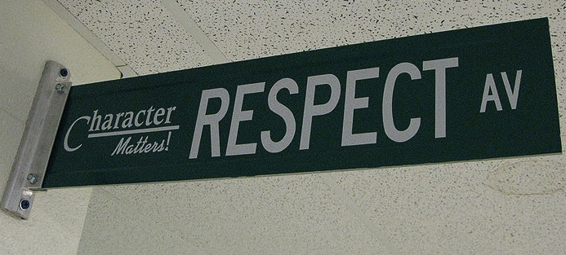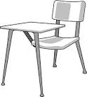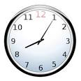

Welcome to English 7. The literacy skills of reading, writing, speaking, listening, comprehending, and thinking are taught at this level. Students gain practice in grammar, punctuation, and writing skills. Assignments include all writing modes:  persuasive, narrative, expository, descriptive and imaginative. The writing process includes ideas and content, organization, sentence fluency and voice. There will also be a strong focus on the integration of properly documented sources, MLA format, and identification of valid sources. In literature we read classic and contemporary literature, including short stories, fantasy, fiction, horror, mythology, dramas, and nonfiction. Personal connections, interpretations and responses to literature are made to show understanding of the text. Vocabulary instruction and growth is emphasized throughout the year Understanding and usage of proper grammar will also be an important part of this class.  Because we are a community of learners, please also expect to work periodically in group situations and to present information to your peers in groups or individually.  At-home reading is expected and is a component of our course.  You will be held accountable for at-home reading by various methods.  Throughout all of our writing, we will also utilize the multi-step writing process to develop, revise, evaluate, and improve our products. We will continue to master literary standards and elements such as tone, conflict, action, conflict, resolution, contrast, cross media comparison and relevance to ourselves and community.

PLEASE ACKNOWLEDGE THAT YOU HAVE READ OVER THIS SYLLABUS WITH YOUR STUDENT BY SENDING ME AN EMAIL AT: [Sblanchette30@gmail.com](mailto:Sblanchette30@gmail.com)

This will count as a participation grade

Students are expected to conduct themselves in a manner which represents the core values of our school: Faith, Respect, Forgiveness and Love

# Course Description

#### Be kind & be respectful.

### Class Expectations

#### Follow directions, ask questions, help others.

#### Participate, volunteer, encourage, and support.

#### Ask permission to leave the room.

#### Be on time & be prepared.

ENGLISH 7

## Homework

Grading Policy

*All grades will be available for students and guardians through our online grade book: Thinkwave.

*Grades are averaged according to the percentage model illustrated below.

*Grade close and work will no longer be accepted 4 school days before report cards will be issued according to the school calendar

*Extra credit is typically not offered but can be discussed

*If you have a question about a grade, a blank, or a missing assignment ASK!

Homework is not busywork. It is necessary for you to complete in order to participate in class the next day or to develop important skills. If you choose not to complete the assigned work, you are missing out on the opportunity to learn and grow. In the past, students who didn’t complete homework struggled to pass English, while students who regularly completed homework succeeded. Homework assignments may include, but are not limited to:

* Independent reading/ comprehension
* Drafting, revising, and writing polished pieces of writing
* Vocabulary activities
* Writing prompts

Expected Homework: 60-90 minutes per night (cumulative of all subjects)

Dress Code

Students are expected to follow dress code every day.

Violation of dress code will lead to the following:

1st offence: verbal warning

2nd offence: written warning

3rd offence: written warning and loss of recess

4th offence: call home and loss of recess

5th offence: office referral

*Offences accrue quarterly

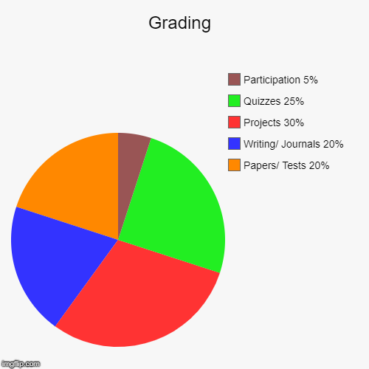

*The mission of Saint Stanislaus School is to provide quality Catholic education in a safe, loving, and nurturing environment and to model for students the values of faith, family, respect, forgiveness and loving service*

**

**Y0U WILL NEED:**

* A Writing Journal and a Grammar Journal
* ELA Binder, tabs and paper
* Writing utensils (pens or pencils)
* A set of colored pencils, crayons, highlighters, and flairs.
* A Gmail account (a flash drive can be used but google docs is a great program to start using)
* A positive attitude, a sense of humor, & an open mind

## Positive & Negative Consequences

Meeting classroom expectations and behaving appropriately in class helps to create a learning environment where you and your classmates feel welcome, safe, and respected.

If you choose to meet the classroom expectations, you will receive a **positive consequence**, such aspraise from teacher, classmates, administration, “Shout Outs,” a positive note or phone call home, special privileges/activities, and awards.

If you choose not to meet the classroom expectations, you will receive a **negative consequence,** such as a verbal warning, a change of seat, a student/teacher conference, a phone call home, a recess detention, a parent/guardian meeting, and/or meeting with the principal.

**Entering Class:** Gather any necessary materials, journals, returned papers located in bins and folders, quickly find your seat, and begin working on assignments according to the agenda posted on the board.

**Bathroom Usage:** Students must ask to use the bathroom. Sign out of the classroom and back in upon return. Excessive bathroom usage, or problems in the bathroom will be addressed.

**Food & Electronic Devices:** Only water is allowed in the classroom. Electronics are to be deposited in the office at the start of the school day. Students seen with electronic devices will be asked to bring them to the office, second and third offences will result in parent contact and further repercussion.

**Exiting Class:** In the last five minutes of class, you will wrap up what you are working on and return materials to the appropriate location, the classroom should be left the way it was found.

**Absences:** If you are absent, it is your responsibility to make up missed assignments. Make-up work will be in your folder on the door. Students have 2 school days to complete missed work before recess is missed. For example: if you are out on a Tuesday you have until Thursday to hand in the work. If work is not handed in, recess will be lost until work is made up. Make-up work should be handed directly to the teacher.

**Late Work:**  Students are expected to hand in work on time (before or during class), this can be done via email if necessary. Due dates for extended projects are firm even if the student is absent from class. Each day an assignment is late will result in a 5-point reduction from the final grade.

**Cheating and Plagiarism:** Plagiarism is defined as the use of or the representation of other people’s words and ideas in whole or in part, as a student’s own work. Cheating is defined as deceitful and dishonest acts relating to academics.

Participation in either of these acts will result in contacting parents and meeting with the principal.

## Classroom Policies & Procedures